pg_dump -U arsen -d volunteer_db -F c -f volunteer_db_backup.dump
createdb -U arsen volunteer_db_backup_test
pg_restore -U arsen -d volunteer_db_backup_test volunteer_db_backup.dump
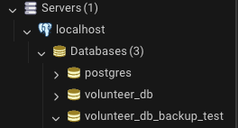
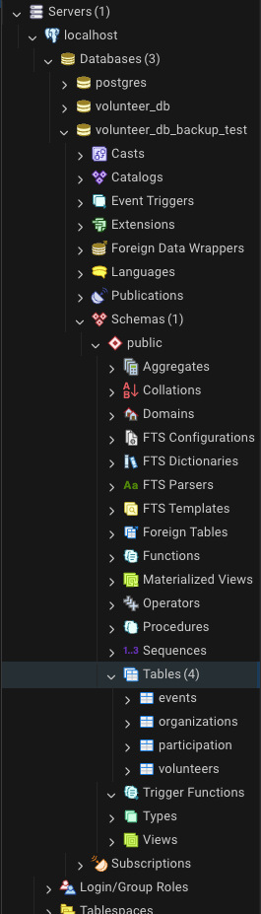
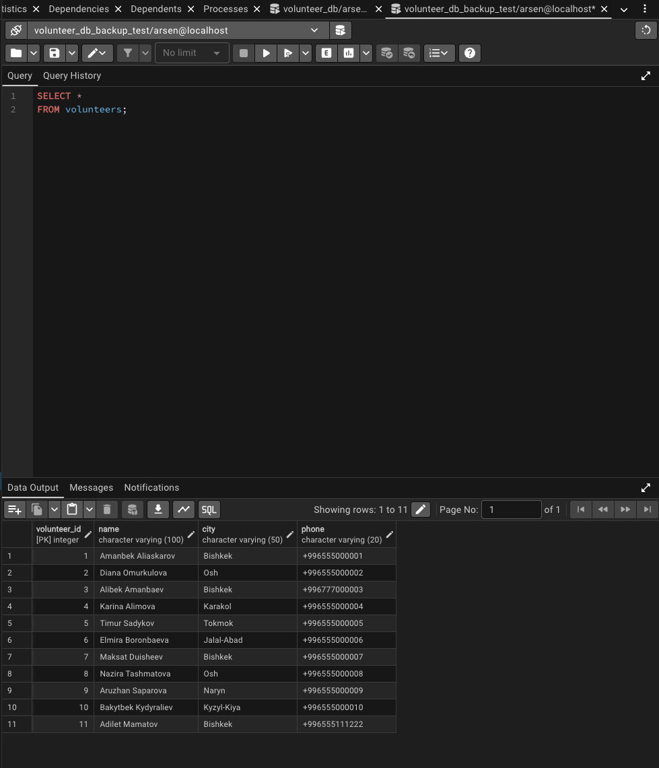
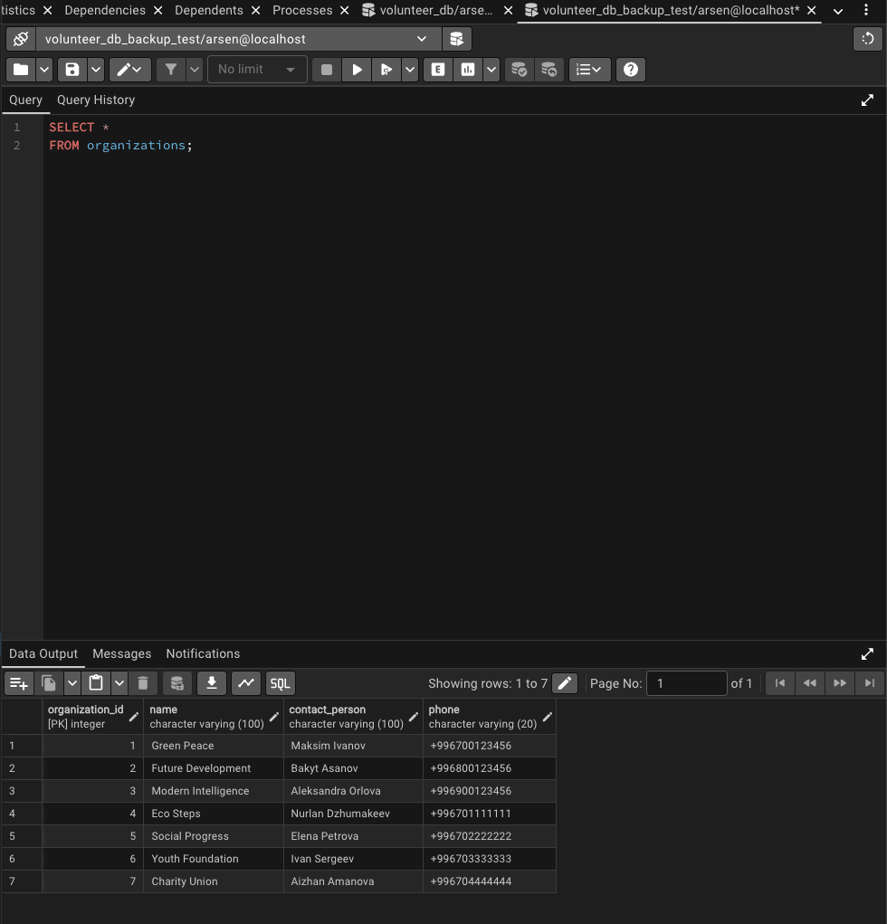
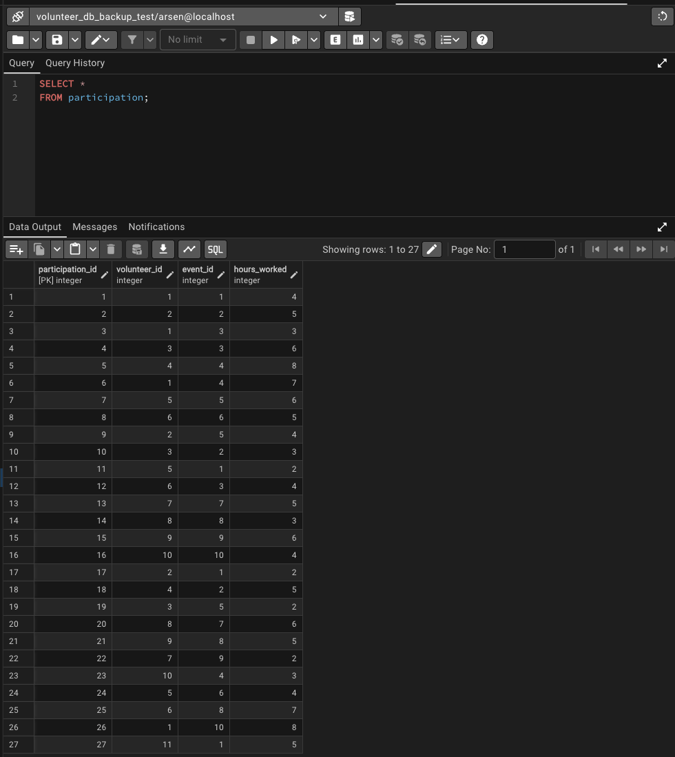
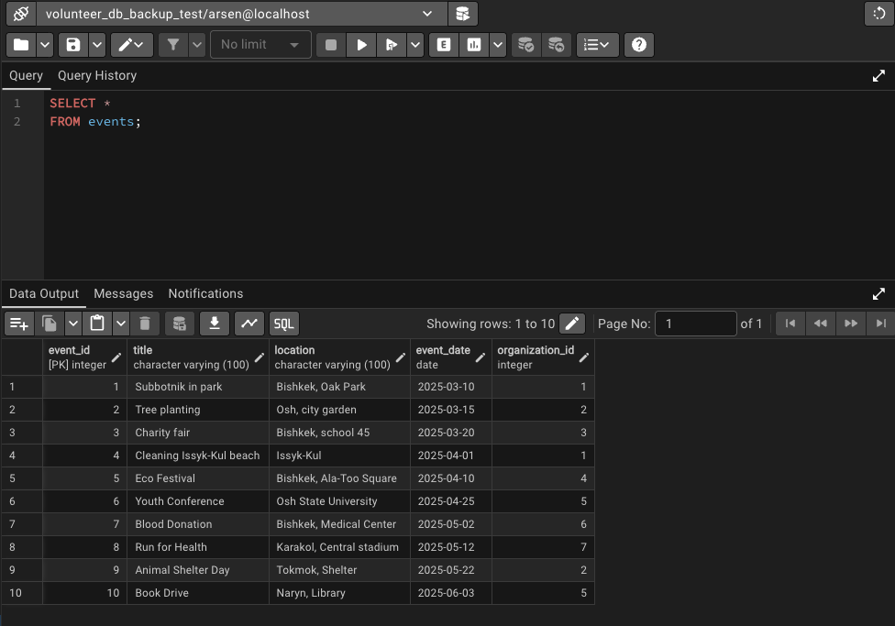

COPY volunteers
TO '/tmp/volunteers.csv'
WITH CSV HEADER;
